Instructions to waste generators Adapt to your process

Thank you for participating in this study about solid waste generation and composition!
You will remain anonymous throughout the study.
For the next eight days, we will visit you daily to collect your waste and provide you with a new bag for the following day.
Your role:
Do not use the regular waste collection service. Deposit all your daily waste into the provided bag without changing your habits. We will pick it up the next day.
If you are not available at collection time, please deposit the bag in a safe spot where we can pick it up or arrange to collect it the next day. We will deposit a new bag.
If you have a habit of using your organic waste to feed animals or for any other use, please continue doing so. Adapt to your process
For your recyclables, please place them in the designated area together with the waste. Adapt to your process
If syringe needles are used for self-medication or if you have to dispose of sharp items, please hand them in separately for the safety of our staff. Adapt to your process
Please inform all your family members // all persons responsible for managing the waste about the study and to use the provided bags for the waste. Adapt to your process (household or non-household audit)
Schedule: Adapt to your process
Today, day 1: Use the provided bag to put all the solid waste generated today
Day 2: We collect the bag from Day 1 and provide a new bag for Day 2.
Day 3-7: We collect the bag from the previous day and provide a new bag
Day 9: We collect the last bag
Example:
Use the bag dated 14.02 to collect all the waste generated on 14.02. We will pick it up the following day and provide you with a new bag.
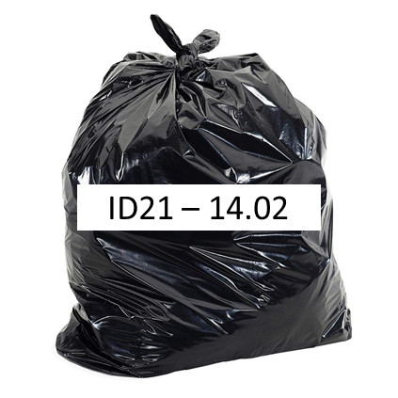
Any questions? Contact: name a person responsible to be contacted and provide contact info.

